Exercise - 2

21_AIE_213

Robotics operating System– SEM-IV

Professor – Dr. Navneeth

Submitted By: Vikhyat Bansal [CB.EN.U4AIE21076]



a) The number_count topic output to the terminal using ros2 topic echo/number_count without reset.

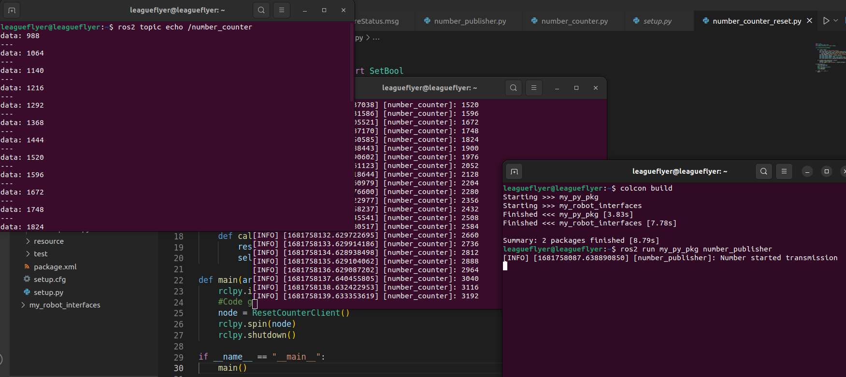

b) The number_count topic output to the terminal using ros2 topic echo/number count with reset.

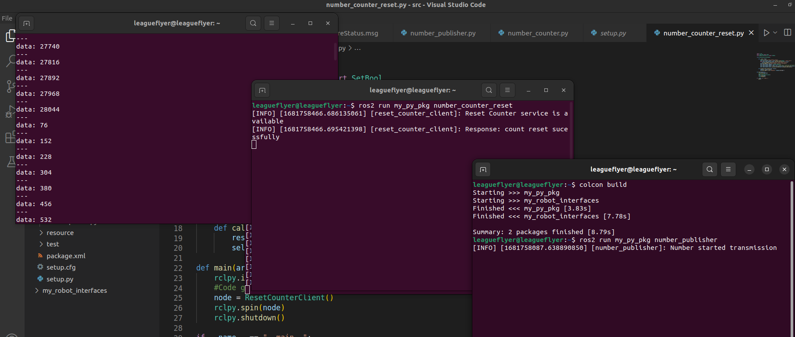

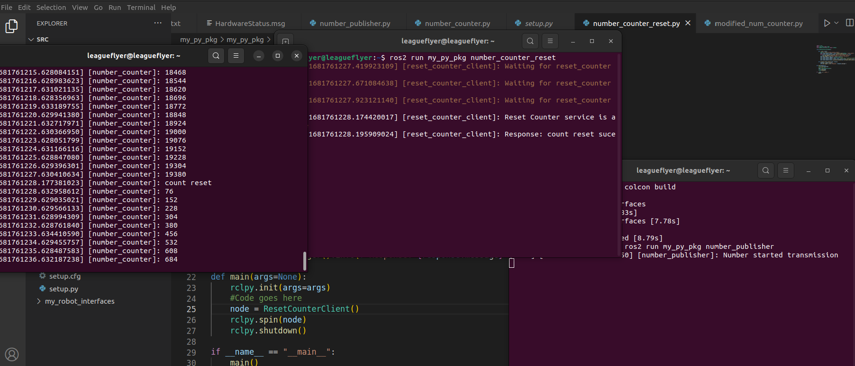

c) Request and response for counter value reset through rqt plugin.

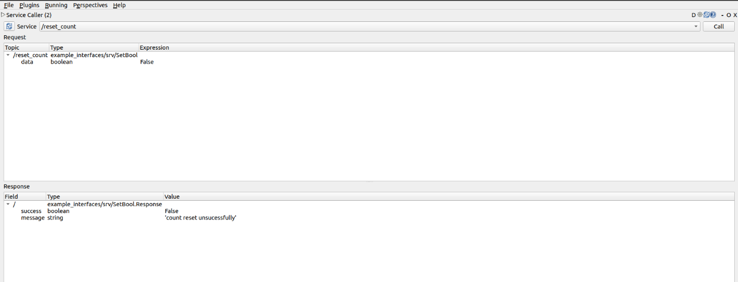False Condition:

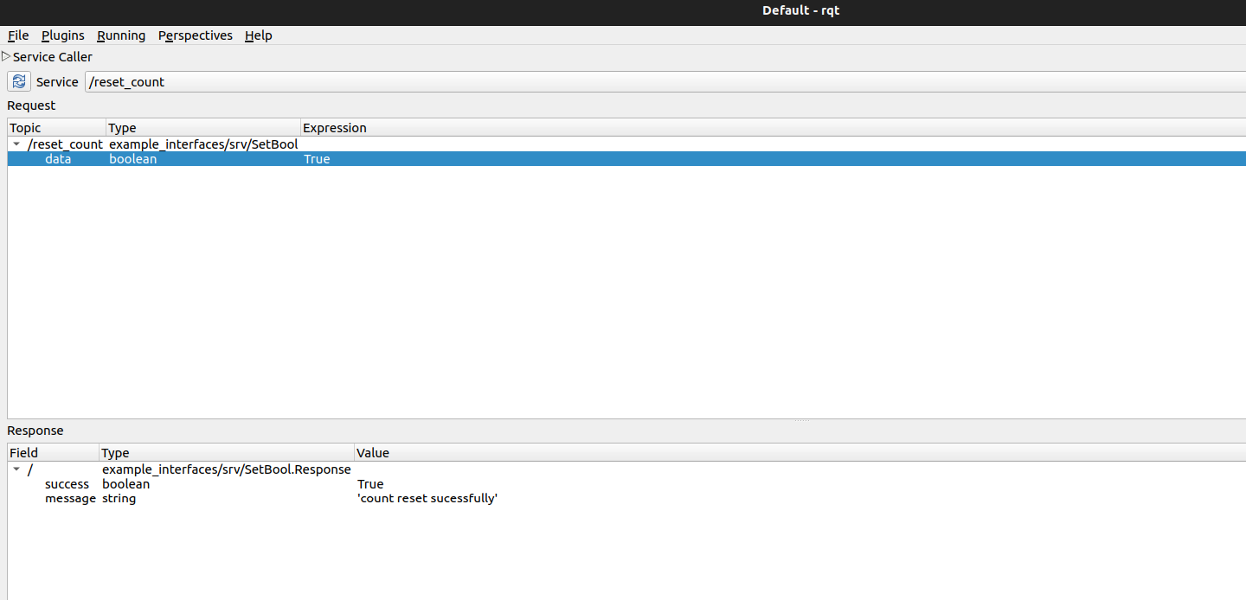True Condition: